**ASSIGNMENT – I**

1. **Write a SQL query to create a table named “employee” with the attributes employee number, employee name, designation, and salary.**

**Ans.** create table employee

(

empno number(4),

ename varchar2(10),

designation varchar2(10),

salary number(8,2)

);

1. **Write a SQL query to display the structure of the table employee.**

**Ans.**  desc employee;

1. **Write a SQL query to insert a row into the table employee.**

**Ans.**  insert into employee values(000,’Abhinav’,’Leader’,888);

1. **Write a SQL query to display all the data present as rows in the table employee.**

**Ans.**  select * from employee;

1. **Write SQL queries to insert rows indirectly into the table employee.**

**Ans.** insert into employee values(&empno,'&ename','&designation',&salary);

Enter value for empno: 001

Enter value for ename: Swagata

Enter value for designation: Teacher

Enter value for salary: 777

old 1: insert into employee values(&empno,'&ename','&designation',&salary)

new 1: insert into employee values(001,'Swagata','Teacher',777)

insert into employee values(&empno,'&ename','&designation',&salary);

Enter value for empno: 011

Enter value for ename: Aditya

Enter value for designation: Singer

Enter value for salary: 555

old 1: insert into employee values(&empno,'&ename','&designation',&salary)

new 1: insert into employee values(011,'Aditya','Singer',555)

insert into employee values(&empno,'&ename','&designation',&salary);

Enter value for empno: 111

Enter value for ename: Atharva

Enter value for designation: Advisor

Enter value for salary: 111

old 1: insert into employee values(&empno,'&ename','&designation',&salary)

new 1: insert into employee values(111,'Atharva','Advisor',111)

1. **Write a SQL query to change the size of the column employee number in the table employee.**

**Ans.** alter table employee modify empno number(7);

1. **Write a SQL query to modify multiple columns in the table employee.**

**Ans.** alter table employee modify (empno number(7), ename varchar2(12));

1. **Write a SQL query to add a new column pin in the table employee.**

**Ans.** alter table employee add pin number(7);

1. **Write a SQL query to create a table named “Student3AB” with the attributes roll number, name, section, and cgpa.**

**Ans.** create table Student3AB

(

roll number(3),

name varchar2(33),

sec char,

cgpa number(3,1)

);

1. **Write SQL queries to insert multiple rows indirectly into the table Student3AB.**

**Ans.** insert into Student3AB values(&roll,'&name','&sec',&cgpa);

Enter value for roll: 12

Enter value for name: Adarsh

Enter value for sec: Y

Enter value for cgpa: 8

old 1: insert into Student3AB values(&roll,'&name','&sec',&cgpa)

new 1: insert into Student3AB values(12,'Adarsh','Y',8)

insert into Student3AB values(&roll,'&name','&sec',&cgpa);

Enter value for roll: 11

Enter value for name: Washamishu

Enter value for sec: Q

Enter value for cgpa: 9

old 1: insert into Student3AB values(&roll,'&name','&sec',&cgpa)

new 1: insert into Student3AB values(11,'Washamishu','Q',9)

insert into Student3AB values(&roll,'&name','&sec',&cgpa);

Enter value for roll: 99

Enter value for name: Faroffisland

Enter value for sec: B

Enter value for cgpa: 65

old 1: insert into Student3AB values(&roll,'&name','&sec',&cgpa)

new 1: insert into Student3AB values(99,'Faroffisland','B',65)

insert into Student3AB values(&roll,'&name','&sec',&cgpa);

Enter value for roll: 111

Enter value for name: Summersnowflake

Enter value for sec: E

Enter value for cgpa: 99

old 1: insert into Student3AB values(&roll,'&name','&sec',&cgpa)

new 1: insert into Student3AB values(111,'Summersnowflake','E',99)

insert into Student3AB values(&roll,'&name','&sec',&cgpa);

Enter value for roll: 77

Enter value for name: Flora

Enter value for sec: W

Enter value for cgpa: 0

old 1: insert into Student3AB values(&roll,'&name','&sec',&cgpa)

new 1: insert into Student3AB values(77,'Flora','W',0)

1. **Write a SQL query to commit all changes made in the tables.**

**Ans.** commit;

1. **Write SQL queries to display the table structure and table contents of the table employee.**

**Ans.** desc employee;

select * from employee;

1. **Write SQL queries to display the table structure and table contents of the table Student3AB.**

**Ans.** desc Student3AB;

select * from Student3AB;

**OUTPUT**

Table employee :-

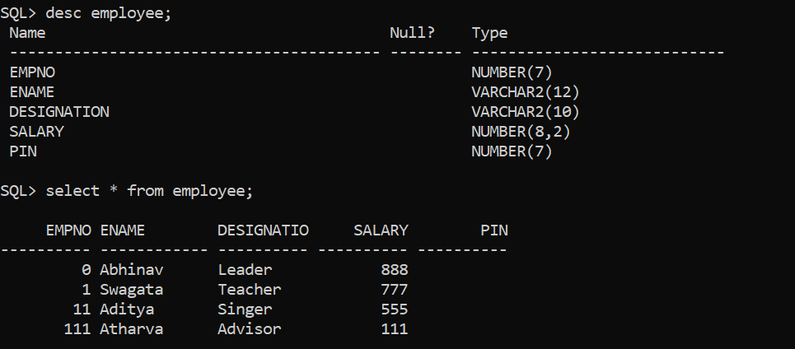

Table Student3AB :-

